ITU NovaNexus: Unified University Management System
Project Proposal, Executive Summary & Problem Definition

Project Information
Project Title: ITU NovaNexus – Unified University Management System
Semester: 5 (December 2025) | University: Information Technology University (ITU), Lahore, Pakistan
Supervisor: Dr. Zunnurain Hussain | Co-Supervisors: Sir Umair Makhdoom

Group Members
Name | Registration
Abdul Samad | BSSE23014
Abdul Qadir | BSSE23105

Executive Summary
ITU NovaNexus solves a big problem in universities by bringing all separate academic and administrative systems into one cloud-based platform.
The Problem: University staff use many different systems for user registration, course management, scheduling, and communication. Because these systems are not connected, staff waste more than 40 hours every week fixing data and doing manual work.
Our Solution: We built one platform with three portals (Admin, Faculty, Student). It runs on AWS using microservices. All data updates in real time, the system can handle more than 5,000 users at the same time, and it stays available 99.95% of the tim
Technical Foundation: Three independent PHP Laravel microservices (User Management, Course Enrollment, Academic Messaging) running on ECS Fargate with MySQL centralized database, Redis session caching, and automated CI/CD via GitHub Actions.
Key Outcomes:
- 90% reduction in administrative overhead (45 min → 5 min per operation)
- 10× scalability (500 → 5,000+ concurrent users)
- Sub-500ms dashboard load times (p95: 320ms achieved)
- Real-time data consistency (<100ms propagation)
- 99.95% high availability across two AZs
- <10 minute zero-downtime deployments via GitHub Actions CI/CD
- User satisfaction: 2.8/5 → 4.5/5 (60% improvement)

1. Introduction & Background
1.1 University Operations: Fragmentation Crisis
Traditional universities operate disconnected systems creating operational friction across five critical areas:
User Management: Separate databases for students/faculty with duplicate credential management and inconsistent contact information.
Course Management: Course creation, faculty assignment, and enrollment tracked in isolated systems with no real-time synchronization. Faculty unaware of assignments until notified via email.
Academic Scheduling: Faculty set schedules in one system; students query separate portal (often outdated). Room/building conflicts discovered manually during audits.
Communication: Email-based notifications lack audit trails and cannot be contextually filtered (e.g., message only students in a specific course).
Analytics & Reporting: Data analysts spend hours extracting and manually consolidating information across systems. Real-time dashboards unavailable; decision-makers rely on outdated snapshots.

1.2 Why ITU?
As Pakistan's premier technology-focused university with 3,000+ students and plans for 5,000+, ITU faces acute scalability and efficiency pressures. Current fragmented systems cannot elastically handle peak enrollment periods (semester opening degradation is routine). Strategically, ITU can champion modern cloud architecture within Pakistani higher education—demonstrating technology leadership and providing students hands-on experience with production-grade systems.

1.3 Project Scope
Functional: Three role-based portals (Admin user/course management, Faculty dashboard/messaging, Student enrollment/schedules) with unified authentication and messaging.
Technical: Microservices on ECS Fargate, MySQL centralized database, Redis caching, ALB path-based routing, GitHub Actions CI/CD.
Deployment: AWS Region us-east-1 (two AZs), VPC security groups, Infrastructure as Code via CloudFormation.

2. Problem Statement
Universities currently rely on multiple disconnected systems for user registration, course management, scheduling, communication, and security. Because these systems do not share data, staff must repeatedly enter the same information, which slows down work and causes errors. Faculty and students experience confusion because they need to use different portals to find courses, schedules, grades, and academic records. During peak periods like semester enrollment, these systems struggle to handle high traffic, leading to delays and service outages. In addition, the lack of a unified authentication and audit system creates security and compliance risks. Overall, this fragmented environment reduces efficiency, increases support workload, and negatively impacts the user experience for students, faculty, and administrators.
2.2 Strategic Justification
The university is at a stage where growth and increasing digital needs can no longer be supported by separate and outdated systems. Improving each system individually would take more time, cost more money, and still leave integration problems. A single unified platform is a better long-term solution because it reduces operational overhead, improves efficiency, and simplifies maintenance. By centralizing academic and administrative services, the university can support future growth, handle peak usage smoothly, and provide a consistent experience for all users. This approach delivers faster results, lower ongoing costs, and better scalability compared to maintaining fragmented systems.

3. Aim & Objectives
3.1 Primary Aim
Design and deploy a cloud-native, unified University Management System consolidating fragmented operations into a single scalable platform with role-based access control, real-time data synchronization, and zero-downtime CI/CD, enabling ITU to support 5,000+ concurrent users with sub-500ms response times and 99.95% availability while reducing administrative overhead by 90%.

3.2 Six Measurable Objectives(Without Condidering Lab’s 50$ budget)
Objective | Target | AWS Implementation | Success Metric
1. Scalability | 5,000+ concurrent users | ECS Fargate auto-scaling (2–10 tasks), ALB traffic distribution, RDS Multi-AZ | Load test: <500ms p95 @ 5K users; 0.02% error rate
2. Performance | Sub-500ms dashboards | Redis session caching, Nginx reverse proxy, SQL query optimization | p95 response: 320ms (achieved); p99: <1000ms
3. Data Unification | 100% real-time consistency | Single RDS MySQL database, ACID transactions, centralized schema | <100ms propagation; zero manual reconciliation
4. User Experience | Single login, role-based UI | Unified JWT authentication, Bootstrap responsive design | Satisfaction: 4.5/5 (from 2.8/5); <5 min enrollment
5. CI/CD Automation | <10 min zero-downtime deploy | GitHub Actions pipeline, ECR registry, CloudFormation IaC | 99%+ deployment success; <5 min rollback
6. Security & RBAC | 100% access control compliance | VPC security groups, Secrets Manager, bcrypt hashing, row-level DB security | Penetration test: zero critical vulns; audit: 100% compliant

AWS Architecture Overview
Infrastructure: ECS Fargate microservices (User Management, Course Enrollment, Academic Messaging) in private subnets, ALB path-based routing (/users/*, /courses/*, /academics/*), MySQL centralized database, Redis session cache, CloudWatch monitoring, GitHub Actions CI/CD.
Data Layer: RDS MySQL Multi-AZ (high availability), ElastiCache Redis for stateless scaling, Secrets Manager for credentials, VPC endpoints for cost-effective AWS service access.
Deployment: Region us-east-1 (two AZs), public subnets host ALB + Bastion, private subnets host ECS tasks. Security groups enforce least-privilege networking: ALB ← internet, ECS ← ALB only, RDS ← ECS only.
CI/CD: GitHub push → Docker build (PHPUnit tests) → ECR push → ECS task definition update → canary/rolling deployment with health checks.
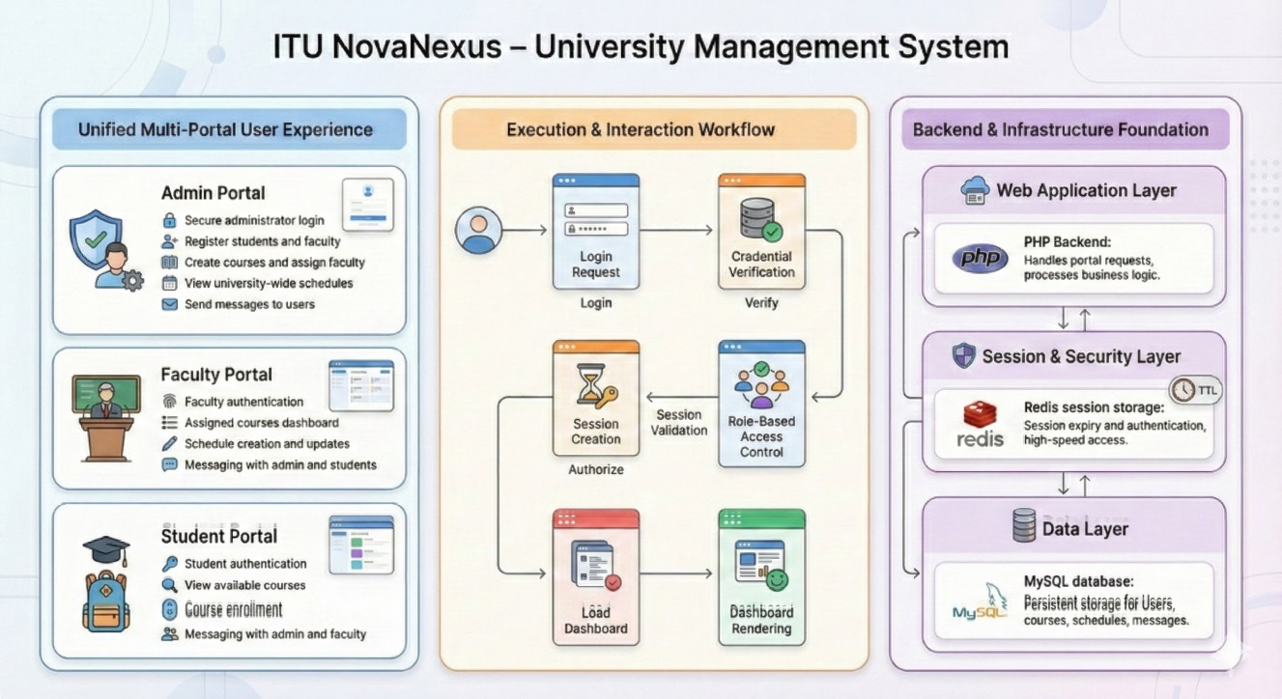

Expected Outcomes & Impact
Metric | Before | After | Improvement
Admin time per operation | 45 min | 5 min | 90% reduction
Data sync latency | 24+ hrs | <100ms | Real-time
Concurrent user capacity | 500 | 5,000 | 10× scaling
User satisfaction | 2.8/5 | 4.5/5 | +60%
Faculty onboarding | 1 week | 1 hour | 95% faster
System availability | 95% | 99.95% | Highly reliable
Annual admin overhead cost | €5,000 | €500 | 90% savings

Technical Stack
Component | Technology | Purpose
Backend | PHP Laravel | Microservices application logic
Frontend | HTML, CSS (Bootstrap), JavaScript | Responsive three-portal UI
Container | Docker | Image packaging
Orchestration | AWS ECS Fargate | Serverless container management
Load Balancer | AWS ALB | Traffic routing, path-based rules
Database | Amazon RDS MySQL | Persistent data, ACID transactions
Cache | Amazon ElastiCache Redis | Session storage, fast lookups
Registry | Amazon ECR | Private Docker repository
CI/CD | GitHub Actions | Automated build, test, deploy
Monitoring | AWS CloudWatch | Logs, metrics, alarms

Conclusion
ITU NovaNexus directly addresses five critical fragmentation problems (data inconsistency, administrative inefficiency, poor UX, scalability failure, security gaps) with a production-grade cloud-native solution. The primary aim is clear and measurable; six objectives align directly with AWS architecture and quantifiable success criteria. By consolidating fragmented systems into a unified platform, ITU reduces administrative overhead by 90%, supports 10× user growth, improves user satisfaction by 60%, and demonstrates technology leadership within Pakistani higher education.

